L 6 School of Antioch (Prof. MJ Ahn)
There is no perfect interpretation.

comparing Alexandria and Antioch School

http://www.monachos.net/library/index.php/patristics/themes/244-two-schools-alexandria-and-antioch

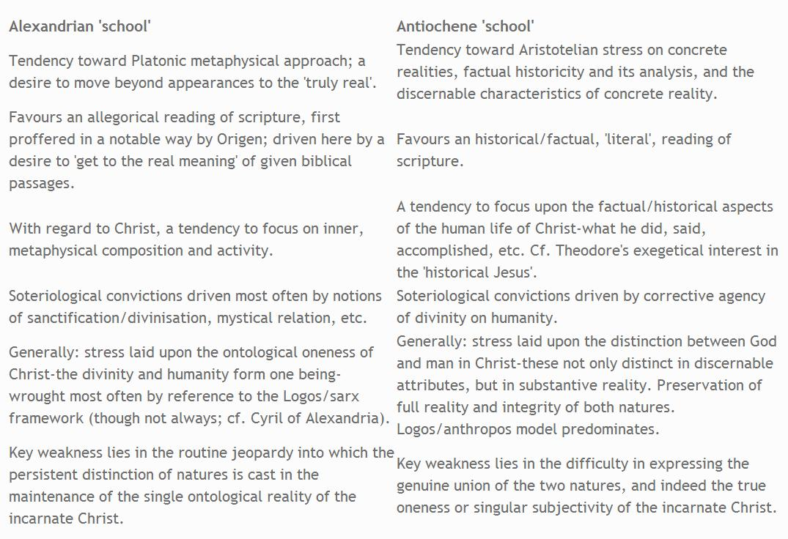

Where is Antioch? Syria.

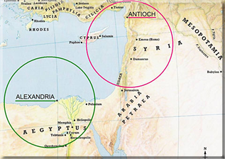

The Four-Fold Sense
"Jerusalem" in Galatians 4:22ff gives a good illustration of the four-fold sense of Scripture.
Four meanings of Jerusalem:

Literal/historical - the city of the Jews
Allegorical - the church of Christ
Moral - indicates the human soul
Anagogical - points to the heavenly city which is the home of us all
Antioch school used both historical and Christocentric Interpreation.

School of Antioch

Reference
LAURIE ANN PINKERT, ANTIOCHENE METHODS OF INTERPRETATION
http://terms.naver.com/entry.nhn?docId=997578&cid=41908&categoryId=41935

Characteristic
used the grammatical(literal)-historical interpretation with original languages.
the influence of Jewish teachers
rejected the allegorical method of interpretation as much as possible.
used Theory to mean the genuine meaning of the text, which Diodorus said included metaphors as well as plain statements. The key to understanding the typological types in the bible was in the understanding of the term theoria, also known as insight. the power of perceiving a spiritual reality.

seeked the real meaning of the text
showed the intention of the author
It is important to reiterate(repeat) that the Antiochene school
of interpretation did not practice genuine historical criticism
and it is too simplistic to characterize the approach
as solely reactionary against the allegorical method.

---
School of Antioch, Christian theological institution in Syria, traditionally founded in about ad 200, that stressed the literal interpretation of the Bible and the completeness of Christ’s humanity, in opposition to the School of Alexandria which emphasized the allegorical interpretation of the Bible and stressed Christ’s divinity.

Flourishing in the 4th–6th century, several significant theologians were Theophilus of Antioch, Diodore of Tarsus, Theodore of Mopsuestia, Nestorius of Constantinople, John of Antioch, Lucian of Samosata, John Chrysostom, and Theodoret of Cyrus or Cyrrhus.

The school of Antioch is best divided into three periods:
the early school (170-early fourth century)
The earliest author known of this period is Theophilus of Antioch. Then there is a gap of a century and in the first half of the fifth century there are three known antiochene authors: the best known is Eusebius of Emesa; other representatives are Acacius of Caesarea and Theodore bishop of Heraklea.
the middle school (350-433)
This period includes at least three different generations: Diodorus of Tarsus, who directed an ἀσκητήριον (school) he may have founded. Among his disciples, the best known are John Chrysostom and Theodorus of Mopsuestia. The main figure of the third generation was Nestorius.
the late school (after 433).
After the Council of Ephesus (431), the School of Antioch loses prestige. Apparently only two later authors are known: Basil of Seleucia and Gennadius of Constantinople.

A. School founded by Dorotheus and Lucius towards the end of the third century, though Farrar regards Diodorus, first presbyter of Antioch, and after 378 A.D. bishop of Tarsus, as the real founder of the school.

the school of Antioch insisted that the literal meaning cannot exclude metaphor. “Literal” here means the customarily acknowledged meaning of an expression in its particular context. For example, when Christ declared that he was the door, the metaphorical meaning of “door” in that context would be obvious. Although metaphorical, this obvious meaning is included in the literal meaning.

Grant, shibpdf. 63-72

Under the influence of Jewish teachers an increasing
respect for the literal meaning of scripture.
Early in the third century an Egyptian bishop named
Nepos wrote a Refutation of the Allegorists.
an interpretation of Genesis by Theophilus of Antioch is literal unlike allegory used by Alexandria school.
Eustathius attacks Origen both for his literalism here and for his ordinary allegorization
Diodorus of Tarsus, composed a book called What is the Difference Between Theory and Allegory.

“Theory,” as we shall see, is the true meaning of the text as the Antiochenes understand it. Finally Theodore of Mopsuestia himself wrote Concerning
Allegory and History Against Origen. The differences between
the schools of Antioch and Alexandria were not slight
The school of Antioch insisted on the historical reality of the biblical revelation.
They kept it in a world of symbols and shadows. They were more Aristotelian than Platonist.
Where the Alexandrines use the word theory as equivalent to allegorical
interpretation, the Antiochene exegetes use it for a sense of
scripture higher or deeper than the literal or historical meaning, but
firmly based on the letter. This understanding does not deny the
literal meaning of scripture but is grounded on it, as an image is
based on the thing represented and points towards it. Both image
and thing are comprehensible at the same time. There is no hidden
meaning which only a Gnostic can comprehend.
The meaning of theory is most clearly evident in the Antiochene
understanding of the prophets.

It is important to reiterate(repeat) that the Antiochene school
of interpretation did not practice genuine historical criticism
and it is too simplistic to characterize the approach as solely reactionary against the allegorical method.

Several Significant Theologians

Theophilus of Antioch( -183 and 185) (Greek: Θεόφιλος ὁ Ἀντιοχεύς)

The theology of Theophilus was rooted in Jewish ideas and the Hebrew scriptures. His death probably occurred between 183 and 185.[3]
We gather from his writings (the only remaining being his apology to Autolycus) that he was born a pagan, not far from the Tigris and Euphrates, and was led to embrace Christianity by studying the Holy Scriptures, especially the prophetical books.[4] He makes no reference to his office in his existing writings, nor is any other fact in his life recorded. Eusebius, however, speaks of the zeal which he and the other chief shepherds displayed in driving away the heretics who were attacking Christ's flock, with special mention of his work against Marcion.[5] He made contributions to the departments of Christian literature, polemics, exegetics, and apologetics. William Sanday[6] describes him as "one of the precursors of that group of writers who, from Irenaeus to Cyprian, not only break the obscurity which rests on the earliest history of the Church, but alike in the East and in the West carry it to the front in literary eminence, and distance all their heathen contemporaries".wiki

Lucian of Antioch (c. 240 – January 7, 312)

known as Lucian the Martyr, was a Christian presbyter, theologian and martyr. He was noted for both his scholarship and ascetic piety. Eusebius of Caesarea notes his theological learning[3] and Lucian's vita (composed after 327) reports that he founded a Didaskaleion, a school. He believed in the literal sense of the biblical text and thus laid stress on the need of textual accuracy. He undertook to revise the Septuagint based on the original Hebrew and the resulting manuscript was popular in Syria and Asia Minor. wiki

Eustathius of Antioch (c. 320 – c. 330)

Eustathius of Antioch, sometimes surnamed the Great, was a bishop and patriarch of Antioch in the 4th century. He was a native of Side in Pamphylia. About 320 he was bishop of Beroea, and he became patriarch of Antioch shortly before the Council of Nicaea in 325. In that assembly he distinguished himself zealously against the Arians, though the Allocutio ad Imperatorem with which he has been credited is hardly genuine.
His anti–Arian polemic against Eusebius of Caesarea made him unpopular among his fellow bishops in the East,
He was an early opponent of allegorical exegesis. In his homily, On the Witch of Endor and Against Allegory, based on 1 Samuel 28, he attacked Origen’s
interpretation because the allegorization was based on too literal a reading of the story and it did not seriously consider the context of the story.

Diodore of Tarsus (Greek Διόδωρος; died c. 390)

was a Christian bishop, a monastic reformer, and a theologian. A strong supporter of the orthodoxy of Nicaea, Diodore played a pivotal role in the Council of Constantinople and opposed the anti-Christian policies of Julian the Apostate. Diodore founded one of the most influential centers of Christian thought in the early church, and many of his students became notable theologians in their own right. wiki
During his priesthood, Diodore founded a monastery and catechetical school near the city of Antioch. It was through this school that Diodore became the mentor of the controversial theologian and liturgist Theodore of Mopsuestia, but also of the legendary homileticist John Chrysostom.[4][5] This school would give rise to the unique Antiochene perspectives on both biblical interpretation and Christology known as the Antiochene School.[6] Ultimately, taken to the extreme, the perspective set out for this school by Diodore led to the teachings of Nestorius, which were first condemned at the First Council of Ephesus in 431.
As one of the first representatives of the school, and often regarded
as the pioneer of the school, he criticized allegory because it made the Bible incomprehensible. Diodore was two of his students, Theodore of Mopsuestia and John Chrysostom. Departing from Alexandrian Christology, Diodore insisted that exegesis focus on the narrative meaning of scripture. For instance, he saw the relation between the Old Testament and the New Testament as more of a typological than a prophetic fulfilment. Diodore also took note of historical events that occurred outside of the biblical narrative such as the peaceful intermingling of various people groups during the age of Hellenism and the Augustan peace that was preparatory for the success of the later Christian mission. Fragments remain from Diodore’s commentaries on the Epistles of Paul, while modern scholars have reconstructed his commentary on Psalms.

Theodore of Mopsuestia(ca. 350 – 428, b Antioch)

His book On Allegory and Historyt against Origen.
Theodore the Interpreter (ca. 350 – 428, b Antioch) was bishop of Mopsuestia (as Theodore II) from 392 to 428 AD. He is also known as Theodore of Antioch, from the place of his birth and presbyterate. He is the best known representative of the middle School of Antioch of hermeneutics.
The exegesis was intellectual and dogmatic;
He had an open eye for the human factor in the Bible, but,
sorry to say, denied the divine inspiration of some of the
Scriptural books. Instead of the allegorical, he defended the
grammutico-historical interpretation,

resented the loss of the traditional Messianic interpretation, and, according to Hesychius of Jerusalem, Theodore was compelled to promise that he would commit his maiden work to the flames.
only allowed Ps 2, 8, 45 to refer Christ.
rejected Ps 22 as referring to Christ, since the ending of the Lxx of it refers to the account of my sins, and since Christ had none(no sin), the Ps could not apply to him.
Theodore’s interpretation of the Song of Solomon
denied the popular mystical approach to this book.

Grant, summary of shibpdf. 63-72
Books with human wisdom, according to Theodore are to be excluded from the canon of scripture. They are not inspired by the Holy Spirit. The book of
Job, for example, was written after the exile by a poet acquainted
with Greek learning. We know he was a poet because he composed
discourses in the name of Job and his friends and even in the
name of God; these discourses bear no relation to reality. He was
acquainted with Greek learning because, according to the Septuagint,
the third daughter of Job is called “horn of Amalthea” (Job
42:14). Unfortunately for this argument, the girl’s name is simply
a mistranslation of qerenhuppuk, “horn for paint,” a cosmetic accessory.
But Theodore was convinced that the wisdom literature
reflects a wisdom merely human and that it cannot be included in
the canon of inspired scripture.
Some of the historical books, such as Chronicles and Ezra-Nehemiah, are merely historical and are therefore to be rejected.”
Theodore’s analysis of the Song of Songs is interesting.
He points out that there is no mention of God in it, and that it is read
publicly neither by Jews nor by Christians.
The exegetical work of Theodore was ordered to be burned by the Second Council of Constantinople in 553 Constantinople,
In Syria and at Nisibis the Nestorians had studied the hermeneutical
work of Aristotle, and had systematized Theodore’s typology
along Aristotelian lines.

Chrysostom(349 – 407)

historical-grammatical interpretaton
more spiritual and practical.
John regarded it as being in every part the infallible Word of God.
His method
was characterized as logical, literal. sober, restrained, commonsensical, grammatical, detailed and historical= matter-of-fact exposition of the text(Pelikan, Preaching of Chrysos. 19)

Erasmus, Luther, Calvin respected him for his historical-grammatical interpretaton

In general, his homiletical theology displays much characteristic of the Antiochian school (i.e., somewhat more literal in interpreting Biblical events), but he also uses a good deal of the allegorical interpretation more associated with the Alexandrian school.[35]wiki

John was born in Antioch in 349 to Greco-Syrian parents. Different scholars describe his mother Anthusa as a pagan[9] or as a Christian, and his father was a high-ranking military officer.[10] John's father died soon after his birth and he was raised by his mother. He was baptised in 368 or 373 and tonsured as a reader (one of the minor orders of the Church).[11]
As a result of his mother's influential connections in the city, John began his education under the pagan teacher Libanius.[12] From Libanius, John acquired the skills for a career in rhetoric, as well as a love of the Greek language and literature.[13]
As he grew older, however, John became more deeply committed to Christianity and went on to study theology under Diodore of Tarsus, founder of the re-constituted School of Antioch. According to the Christian historian Sozomen, Libanius was supposed to have said on his deathbed that John would have been his successor "if the Christians had not taken him from us".[14]
John lived in extreme asceticism and became a hermit in about 375; he spent the next two years continually standing, scarcely sleeping, and committing the Bible to memory. As a consequence of these practices, his stomach and kidneys were permanently damaged and poor health forced him to return to Antioch.[15]
His straightforward understanding of the Scriptures – in contrast to the Alexandrian tendency towards allegorical interpretation – meant that the themes of his talks were practical, explaining the Bible's application to everyday life. Such straightforward preaching helped Chrysostom to garner popular support. He founded a series of hospitals in Constantinople to care for the poor.[19]

Grant, shibpdf. 63-72
John Chrysostom, archbishop of Constantinople, was like Theodore a pupil of Diodorus of Tarsus; he continued to make use of his master’s literalist method in his sermons and commentaries. While Chrysostom does not rigidly exclude allegorization, he usually restricts himself to typology. Indeed, he
criticizes Paul’s use of language in Galatians 4:24:
By a misuse of language he called the type allegory. What he means
is this: the history itself not only has the apparent meaning but also
proclaims other matters; therefore it is called allegory. But what did
it proclaim? Nothing other than everything that now is.
Here Chrysostom reflects the Antiochene concept of theory.

The great humanist Erasmus described John Chrysostom‘s interpretative art using this exact metaphor: ―There is nothing so hidden in the depths of Sacred literature that Chrysostom could not bring forth with dramatic clarity and make it accessible to the common people. Chris L. de Wet, University of South Africa

Theodoret of Cyrus or Cyrrhus (Greek: Θεοδώρητος Κύρρου; c. AD 393 – c. 458/466)
was an influential theologian of the School of Antioch, biblical commentator, and Christian bishop of Cyrrhus (423–457). He played a pivotal role in several 5th-century, Byzantine Church controversies that led to various ecumenical acts and schisms. He is called "blessed" in the Eastern Orthodox Church,[1] and some Chalcedonian and East Syrian Christians regard him as a saint.
The most significant works of Theodoret are those of exegesis.
A chronology of the composition of these works can be developed by studying references in the latter works to the earlier works. The commentary on the Song of Songs, written while he was a young bishop, though not before 430, precedes Psalms; the commentaries on the prophets were begun with Daniel, followed by Ezekiel, and then the Minor Prophets. Next that on the Psalms was completed before 436; and those on Isaiah, Jeremiah, and the Pauline Epistles (including Hebrews), before 448. Theodoret's last exegetical works were the interpretations of difficult passages in the Octateuch and Quaestiones dealing with the books of Samuel, Kings, and Chronicles, written about 452 to 453.
Excepting the commentary on Isaiah (fragments preserved in the catenae) and on Galatians ii.6-13, the exegetical writings of Theodoret are extant. Exegetical material on the Gospels under his name in the catenae may have come from his other works, and foreign interpolations occur in his comments on the Octateuch.
His representation of orthodox doctrine consists of a collocation of Scripture passages.
The biblical authors are, for Theodoret, merely the mouthpieces of the Holy Spirit, though they do not lose their individual peculiarities. By the unavoidable imperfection of the translations, he states, the understanding is encumbered. Not familiar with Hebrew, Theodoret uses the Syriac translation, the Greek versions, and the Septuagint.
In principle his exegesis is grammatical-historical; and he criticizes the intrusion of the author's own ideas. His aim is to avoid a one-sidedness of literalness as well as of allegory. Hence he protests against the attributing of The Song of Songs to Solomon and the like as degrading the Holy Spirit. Rather is it to be said that the Scripture speaks often "figuratively" and "in riddles." In the Old Testament everything has typological significance and prophetically it embodies already the Christian doctrine. The divine illumination affords the right understanding after the apostolic suggestion and the New Testament fulfilment. Valuable though not binding is the exegetical tradition of the ecclesiastical teachers. Theodoret likes to choose the best among various interpretations before him, preferably Theodore's, and supplements from his own. He is clear and simple in thought and statement; and his merit is to have rescued the exegetical heritage of the school of Antioch as a whole for the Christian Church.

